Mevlana Exchange Programs for Students

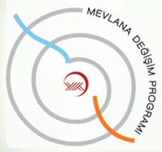
In the Food Engineering Department, students have studied abroad at other universities (Ruslan Adil Akai Tegin and Akylai Chynalieva, Mersin University, 2009-2010), through the Mevlana Program (Rakhat Uulanbek uulu, Akdeniz University, 2015-2016) and through DAAD (J. Iskakova, Germany).

More information about the Mevlana program can be found here: http://mdp.manas.edu.kg/
Useful links about the Mevlana Program:
- http://mdp.manas.edu.kg/program_yonetmeligi.pdf
- http://mdp.manas.edu.kg/index.php/mevlana-degisim-program-sunusu
- http://mdp.manas.edu.kg/index.php/2013-05-20-04-56-30
- http://mdp.manas.edu.kg/index.php/2015-03-12-05-45-10
- http://mdp.manas.edu.kg/index.php/oenemli-bilgiler

DAAD Student Exhange Programs
Doctorate student Janyl Iskakova spent the 2015-2016 academic year working on research for her PhD dissertation at the Technical University of Berlin in German through the DAAD program.

More information about the DAAD program can be found here: http://www.daad.kg/ru/
Useful information about the DAAD Program: http://www.daad.kg/ru/23295/index.html

